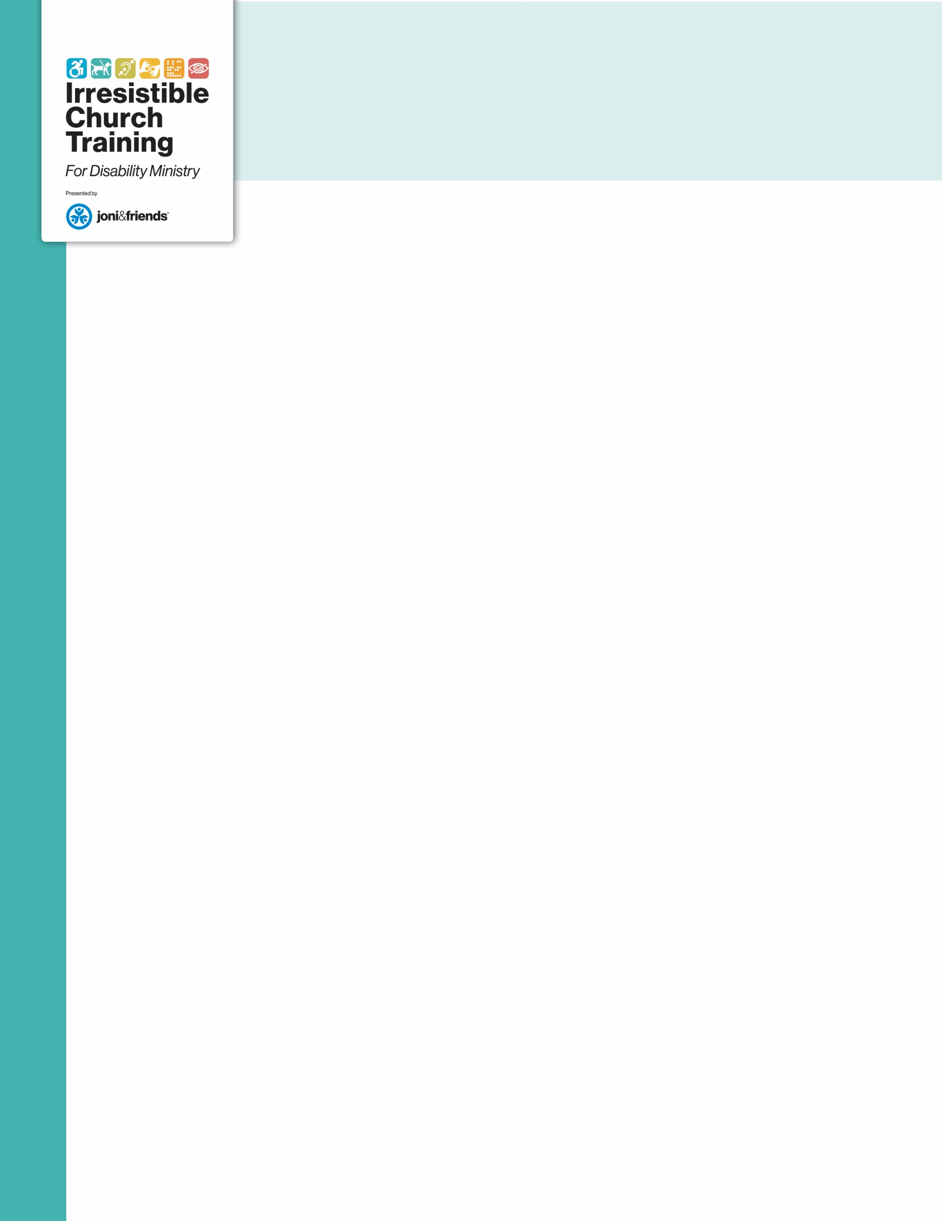
Family Ministry Profile

Use these questions to learn how to effectively accomplish the mission and vision of your church in the life of a family affected by disability.

Family Church Involvement
- How long have you attended our church?
- What brought you here?
- How is our church already meeting the unique needs of your family?
- What has hurt your family in the past regarding your family’s special needs?
- What parts of church life do you and your family desire to participate in?
- What prevents your family from participating and serving in church programs?
- What supports are necessary for you and your family to fully participate in the Body of Christ?
Disability Profile
- Name of child/adult with a disability:
- Age and school/program placement:
- Participates in (church ministry):
- Disability:
- This disability manifests the following complications:
- This child/adult loves the following:
- What do you need us to know or understand about your family member?
Child Discipleship Profile
- The child/adult with a disability would best be discipled: (choose the appropriate answers)
  - In the typical setting for their age group with no supports
  - In the typical setting for their age group with a buddy who is:
    - An adult
    - An older student
    - A peer
  - In a separate classroom with a trained teacher and other students with disabilities
  - A combination of the above choices that would look like:
For more information, visit irresistiblechurch.org
  - Why do you believe your family member will grow spiritually in this setting?
  - Why do you not believe your family member will grow spiritually in other settings?
  - What is your family members’ current spiritual state?
  - What is your dream for your family member?

Sibling(s) Discipleship Profile
- Name of sibling:
- Age:
- Gender:
- This child is affected by their sibling’s disability in the following ways:
- What is your child’s current spiritual state?
- What is your dream for your child?
- From what do you believe this child would benefit spiritually?

Who else would benefit from this conversation?

For more information, visit irresistiblechurch.org

